Database Systems in E-Commerce: An Analysis of OpenCart Database Schema

An Assignment submitted in partial fulfillment of the requirements for the degree of
Bachelor of Science
in
Computer Science

CS 3306: Databases 2

Term 4 - 2025
University of The People

Instructor: Dr. Afrah Nazir

April 30th 2026

Database Systems in E-Commerce: An Analysis of OpenCart Database Schema
Recently I came across OpenCart, a free open source e-commerce platform for online merchants that provides a professional and reliable foundation from which to build a successful online store (OpenCart, 2026a). OpenCart documentation guides developers who need to use its interface by providing more details about the aspects involved with setting up an e-commerce store: complete with keeping it up to date to the latest version, meeting the technical requirements, accessing the admin panel, and uninstallation. While going through the documentation, I came across the OpenCart database schema to see how it was designed, refer to Appendix 1 (OpenCart, 2026b). This experience revealed how database systems are fundamentally integrated into every aspect of modern e-commerce operations, supporting the complete range of commercial activities from presale interactions to post-sale customer support.
E-commerce refers to the process of carrying out various activities related to commerce through electronic means, primarily through the internet (Silberschatz et al., 2001). The types of activities include presale activities needed to inform potential buyers about products or services, the sale process which includes negotiations on price and quality, payment processing, delivery coordination, and customer support services (Silberschatz et al., 2001). Database systems are used extensively to support these activities, with some applications being straightforward while others present complex development challenges. The OpenCart database schema exemplifies this comprehensive integration, with tables specifically designed to handle product catalogs, customer management, order processing, and payment systems (OpenCart, 2026b).
The architecture of e-commerce systems demonstrates the critical role of databases in managing both front-end and back-end operations. Front-end systems rely on databases for user interfaces, product catalogs, shopping cart functionality, and customer authentication (Silberschatz et al., 2001). The OpenCart database schema supports these core front-end functions through tables such as oc_product and oc_product_description, which store comprehensive product information including names, descriptions, prices, and specifications (OpenCart, 2026b). Customer authentication and management are handled by the oc_customer table, which stores user credentials, personal information, and account status, while the oc_customer_group table enables segmentation of customers into different categories for targeted marketing and pricing strategies (OpenCart, 2026b). The shopping cart functionality is supported by the oc_cart table, which temporarily stores selected items before purchase, enabling customers to review and modify their selections before proceeding to checkout.
Modern e-catalogs represent sophisticated database applications that go far beyond simple product listings. According to Silberschatz et al. (2001), advanced e-catalogs provide hierarchical organization, powerful search capabilities, product comparison features, and extensive personalization options. The OpenCart database schema implements these features through a comprehensive set of interconnected tables. Product categorization is achieved through the oc_category and oc_category_description tables, which create hierarchical product organization that allows customers to navigate through intuitive category structures (OpenCart, 2026b). The oc_product_to_category table establishes many-to-many relationships between products and categories, enabling products to appear in multiple relevant categories. Advanced search capabilities are supported by the oc_product_attribute table, which stores detailed product specifications that can be used for faceted search and filtering (OpenCart, 2026b). Product comparison features are enabled through the oc_product_related table, which stores associations between similar or complementary products, allowing customers to compare features and make informed purchasing decisions.
Order processing and management represent another critical area where database systems play a fundamental role in e-commerce operations. The OpenCart database schema includes a comprehensive set of tables designed to handle the complete order lifecycle from creation to fulfillment (OpenCart, 2026b). The oc_order table serves as the central repository for order information, storing customer details, shipping addresses, payment methods, and order status (OpenCart, 2026b). Individual order items are tracked through the oc_order_product table, which maintains detailed records of each product purchased, including quantities, prices, and any applicable discounts. Order history and status updates are managed by the oc_order_history table, which provides a chronological record of all changes to order status, enabling both merchants and customers to track order progress through the fulfillment process (OpenCart, 2026b). This comprehensive order management system ensures that all aspects of order processing are accurately recorded and easily accessible for customer service and analytical purposes.
Payment settlement and financial transaction processing represent perhaps the most database-intensive aspects of e-commerce. Secure payment processing requires databases to store encrypted financial information, maintain transaction records, and integrate with payment gateways (Silberschatz et al., 2001). The OpenCart database schema addresses these requirements through several specialized tables. The oc_order_total table manages the financial breakdown of orders, including subtotals, shipping costs, taxes, and final totals (OpenCart, 2026b). Promotional pricing and discount management are handled by the oc_coupon and oc_coupon_history tables, which store coupon codes, discount values, and usage records (OpenCart, 2026b). Gift certificate and voucher functionality is supported by the oc_voucher and oc_voucher_history tables, enabling customers to purchase and redeem gift certificates while maintaining accurate records of their usage. These financial tables work together to ensure that all monetary transactions are accurately recorded, properly calculated, and securely stored, providing both merchants and customers with reliable financial records for accounting and reconciliation purposes.
Customer relationship management and post-sale support represent the final critical area where database systems enable comprehensive e-commerce functionality. According to Silberschatz et al., 2001, customer support and post-sale service are essential components of successful e-commerce operations. The OpenCart database schema includes several tables designed to support ongoing customer relationships and service delivery. The oc_review table enables customers to provide feedback and ratings for products they have purchased, creating valuable social proof and helping other customers make informed decisions (OpenCart, 2026b). Customer activity and engagement are tracked through the oc_customer_activity table, which records various customer interactions such as logins, password changes, and other account activities (OpenCart, 2026b). Return and refund processing is supported by the oc_return table, which manages product return requests, reasons for returns, and resolution outcomes. These customer-focused tables enable merchants to maintain comprehensive customer profiles, track engagement patterns, and provide personalized service that builds long-term customer relationships and encourages repeat business.
In conclusion, the OpenCart database schema provides a comprehensive example of how database systems form the foundation of modern e-commerce operations. Through its extensive network of interconnected tables, the schema demonstrates how databases enable the complete spectrum of commercial activities from initial customer engagement through post-sale support. The integration of product management, customer relations, order processing, and payment systems into a unified database architecture illustrates the critical role that databases play in enabling efficient, secure, and scalable e-commerce operations. As e-commerce continues to evolve with new technologies and changing consumer expectations, database systems like the OpenCart schema will continue to serve as the essential infrastructure that supports digital commerce worldwide, enabling merchants to provide increasingly sophisticated and personalized shopping experiences while maintaining the security, reliability, and performance that customers expect from online retailers.

References
OpenCart. (2026a). Introduction. https://docs.opencart.com/
OpenCart. (2026b). Database schema. https://docs.opencart.com/developer-guide/database-schema
Silberschatz, A., Korth, H.F., & Sudarshan, S. (2001). Database System Concepts (4th ed.). New York, NY: McGraw-Hill.

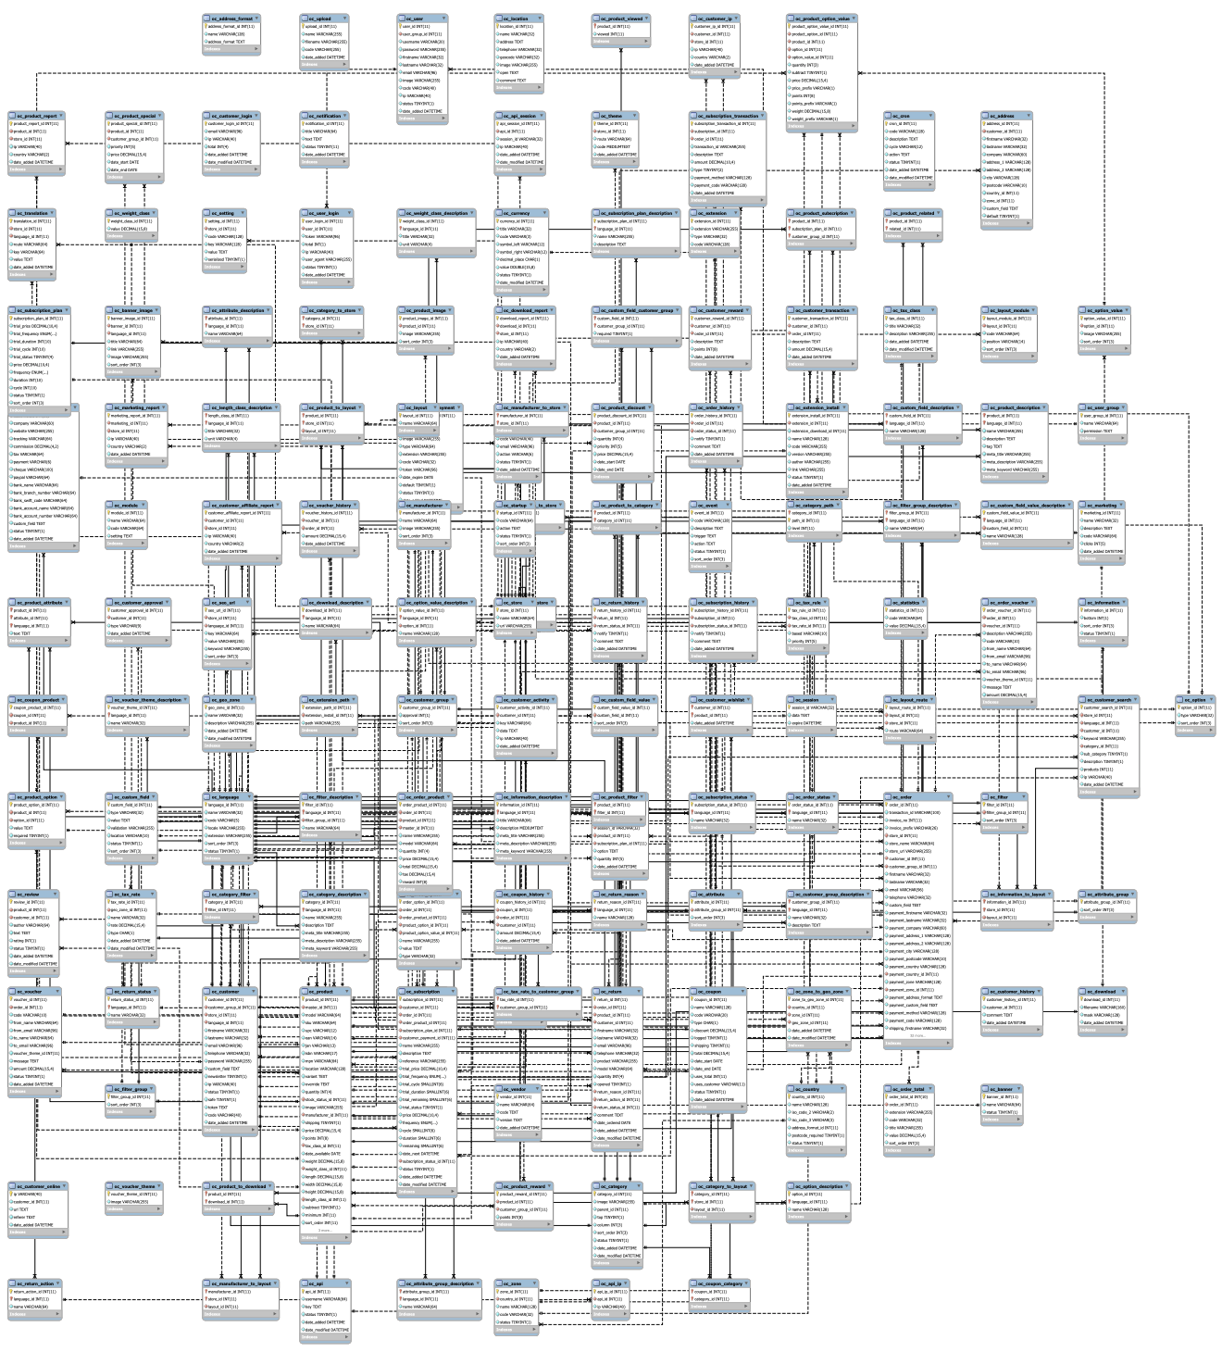Appendix 1: OpenCart Database Schema

